Jessica Weed

GST325

1/23/2015

Origami and Technology



Science can be defined as the field in which people explain each part of life from the miracle of birth to the stars in the sky. It is concrete and uses the scientific method to test hypotheses in order to answer a question with out bias or error by repetition and reliability in testing. Science and origami fit together in an unexpectedly perfect way. There are many examples in the world today that really show how each can use the other to become more advanced and developed. Applications of origami in a scientific way can be seen in every aspect of life and just a few are investigated more thoroughly. Technology origami or origami engineering is the use of origami to develop and further useful tools in the modern world using the benefits of origami. Its effectiveness can be seen in many examples from airbags to telescopes or tools that go into space.

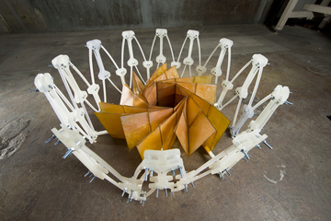

Each source goes farther into depth discussing the technology and usefulness of origami in the scientific field. Lang’s website is quite helpful and breaks down each of the scientific connections into areas including mathematics, technology and computation. By focusing on these areas, he is able to look more deeply into origami by defining each of these fields and then explaining their connection. Lang goes more in depth on the topic of technology origami and discusses the many more specific examples of it. He talks about the requirements for the connection between origami and technology: “the technological object is thin and sheet-like; it must be opened out and flat at its destination… but must be much smaller for the journey” (Lang). This is the perfect definition of technology origami. Although his description is brief, he provides links to other articles that further help the reader understand the importance of origami in technology development.

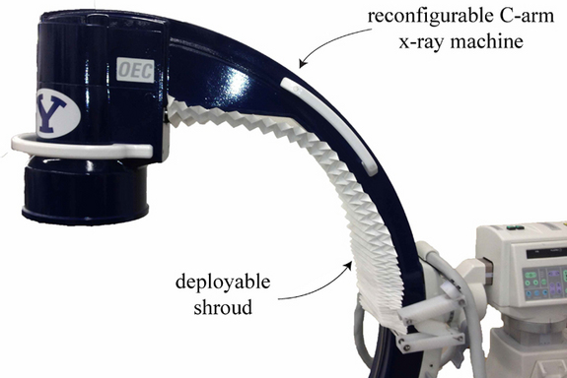

One of the articles talks about 9 of the most amazing uses of origami in the modern world and some of them are quite spectacular. Surprisingly, a good deal of these are quite futuristic- for example robots and space devices- and many are used for common problems or objects that are used daily. Airbags, something humans rely on to save their lives in case of a car accident are commonly folded using origami so they lay flat when not in use. Scientists and origami artists have been able to work together to create a heart stent that does not expand until it is in the correct location in the body, which most would consider an extremely futuristic accomplishment. One of the most amazing uses of origami is to better understand the folding properties of DNA in order to properly deliver drugs. Although these are not currently in use, it is a hope one day that the use of these drugs would be to accurately diagnose a sick person.

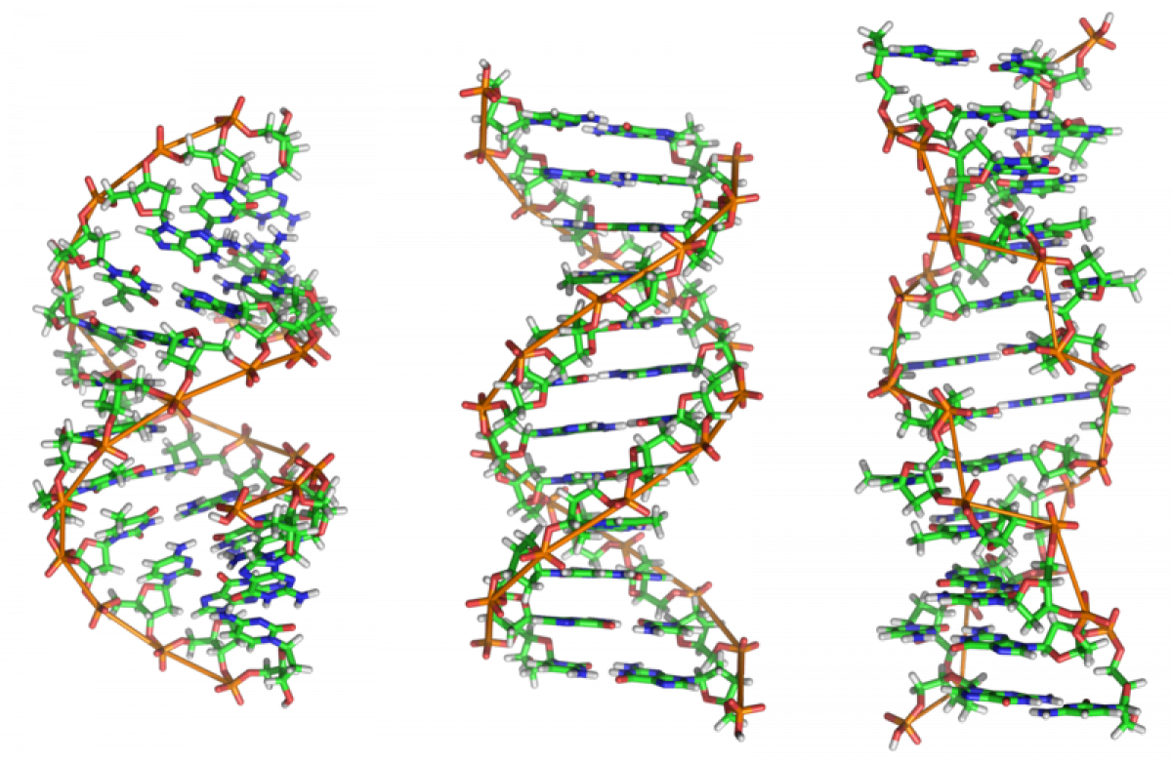

The last source, from Live Science, also discusses some of the inventions that have been created by combining origami and technology. The article mostly focuses on the medical aspect of technology origami. But it furthers this this discussion by talking about the barriers origami has overcome in terms of the traditional constraints most building materials must withstand. Most importantly, the article talks about what could come in the future and the huge amount of expansion origami is really taking throughout the world.

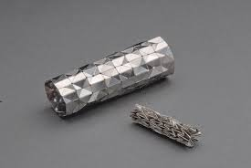

I chose this connection between technology and origami because I’m extremely interested in the practical uses of origami in the modern world and this topic seems to have the most to do with the engineering of new and applied uses of origami. I thought the list of uses would be short and obvious, but this list was far more extensive and used in more fields than I thought. Who thought there would one day be robots that could use origami to self-construct and then use small engines to “scuttle” off? The idea of modern origami is intriguing because when you really think about it, there are so many possibilities. Who knows what can be combined with origami to create something even more impeccable and helpful in our modern world.

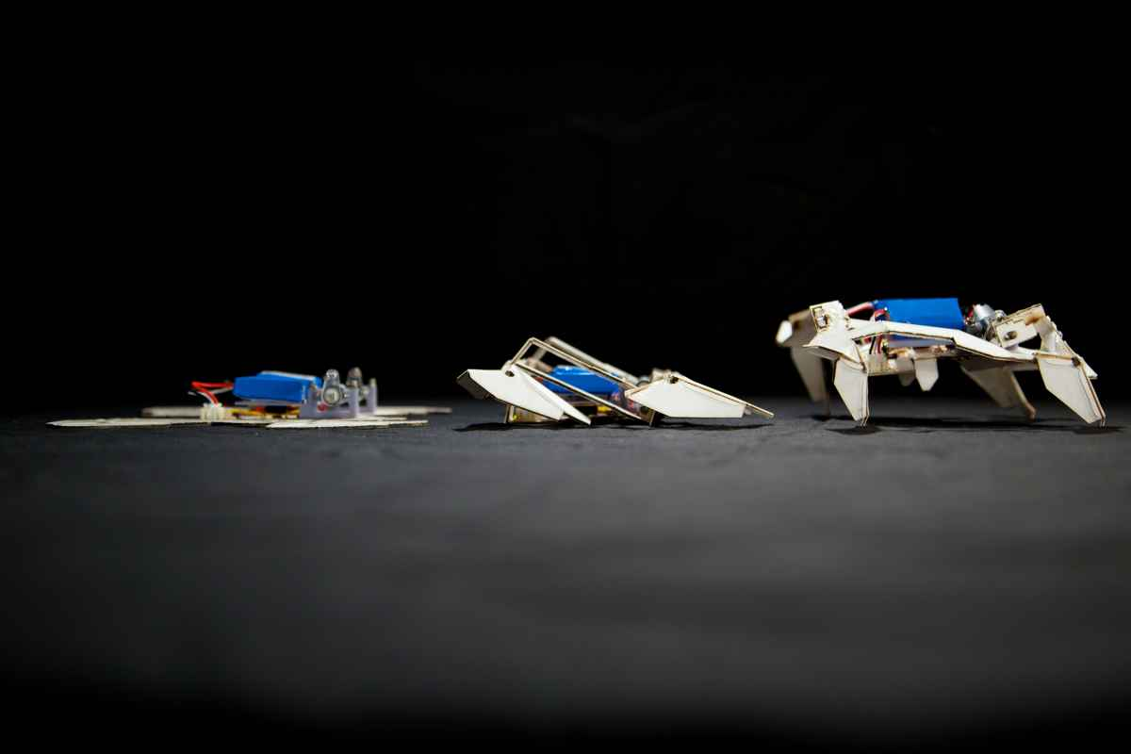

References

Main, Douglas. "From Robots To Retinas: 9 Amazing Origami Applications." *Popular Science*. N.p., 7 Aug. 2014. Web. 13 Jan. 2015.

"Science, Mathematics, and Technology." *Robert J. Lang Origami*. N.p., 2015. Web. 13 Jan. 2015.

Varrasi, John. "How the Future of Origami Engineering Is Unfolding." *LiveScience*. TechMedia Network, 13 Dec. 2014. Web. 14 Jan. 2015.